# CS 255 Business Requirements Document Template

Jadyn Washington

CS-255

Complete this template by replacing the bracketed text with the relevant information.

This template lays out all the different sections that you need to complete for Project One. Each section has guiding questions to prompt your thinking. These questions are meant to guide your initial responses to each area. You are encouraged to go beyond these questions using what you have learned in your readings. You will need to continually reference the interview transcript as you work to make sure that you are addressing your client’s needs. There is no required length for the final document. Instead, the goal is to complete each section based on your client’s needs.

**Tip:** You should respond in a bulleted list for each section. This will make your thoughts easier to reference when you move into the design phase for Project Two. One starter bullet has been provided for you in each section, but you will need to add more.

## System Components and Design

### Purpose

*What is the purpose of this project? Who is the client and what do they want their system to be able to do?*

* Driver Pass aims to create a user-friendly platform that helps students prepare for their driving test with confidence. It offers resources like practice exams, step-by-step guides, and study tools to make learning simple and effective.

### System Background

*What does Driver Pass want the system to do? What is the problem they want to fix? What are the different components needed for this system?*

* Driver Pass is building a platform where students can register, take practice tests, and book driving lessons. Aiming to become a top driver training provider, the system will include scheduling, instructor feedback, student info management, and progress tracking to prepare users for their driving exams.

### Objectives and Goals

*What should this system be able to do when it is completed? What measurable tasks need to be included in the system design to achieve this?*

* The system must manage key functions like tracking changes by users and admins, preventing double bookings for instructors or vehicles, and integrating with the local DMV. Students should be able to choose packages check test statuses and update personal or payment info all with changes logged. Instructors need to leave feedback, and management must access data remotely. Core features include real-time updates clear test result displays and reliable scheduling.

## Requirements

### Nonfunctional Requirements

*In this section, you will detail the different nonfunctional requirements for the Driver Pass system. You will need to think about the different things that the system needs to function properly.*

#### Performance Requirements

*What environments (web-based, application, etc.) does this system need to run in? How fast should the system run? How often should the system be updated?*

* The system will run on a cloud-based web platform for high performance and real-time updates. It must prevent duplicate bookings and allow users to instantly view available slots and instructors. Test results should appear immediately after completion. Frequent system updates are essential, including the ability to adjust driving packages and quickly apply changes to remain DMV compliant.

#### Platform Constraints

*What platforms (Windows, Unix, etc.) should the system run on? Does the back end require any tools, such as a database, to support this application?*

* The system must be cross platform compatible with Windows macOS Unix and accessible via web browsers and mobile devices (iOS and Android). A reliable backend database will manage user data schedules test results and payments supported by a web server and development framework to ensure smooth efficient performance.

#### Accuracy and Precision

*How will you distinguish between different users?* *Is the input case-sensitive? When should the system inform the admin of a problem?*

* The system will use unique login credentials for students, instructors, and admins, combining usernames or emails with case-sensitive passwords for security. Usernames and emails may be case-insensitive for ease of use. Admins will receive real-time alerts for issues like scheduling conflicts, payment failures, or data errors, allowing quick resolution and smooth system performance.

#### Adaptability

*Can you make changes to the user (add/remove/modify) without changing code? How will the system adapt to platform updates? What type of access does the IT admin need?*

* Users can be added, removed, or modified through a user management interface, allowing admins to make changes without altering the code. The system will use version control and modular coding to adapt to platform updates, ensuring ongoing compatibility. IT admins will have full backend access to manage accounts, troubleshoot issues, monitor performance, and apply updates as needed.

#### Security

*What is required for the user to log in? How can you secure the connection or the data exchange between the client and the server? What should happen to the account if there is a “brute force” hacking attempt? What happens if the user forgets their password?*

* Users log in with a unique username/email and secure password with optional MFA for added security. All connections and stored data are encrypted with HTTPS and SSL/TLS. After multiple failed login attempts accounts are locked temporarily and both the user and admin are notified. CAPTCHA helps prevent automated attacks, and secure password recovery is available via email verification.

### Functional Requirements

*Using the information from the scenario, think about the different functions the system needs to provide. Each of your bullets should start with “The system shall . . .” For example, one functional requirement might be, “The system shall validate user credentials when logging in.”*

1. The system shall validate user login credentials.
2. The system shall enable scheduling of driving lessons without conflicts.
3. The system shall show test history and status.
4. The system shall show real-time instructor and car availability
5. The system shall connect to the local DMV for compliance updates.
6. The system shall allow admin remote access to data

### User Interface

*What are the needs of the interface? Who are the different users for this interface? What will each user need to be able to do through the interface? How will the user interact with the interface (mobile, browser, etc.)?*

* An interface is important for websites because it allows users to interact easily, find information quickly, and use the site effectively. For this instance the interface for Driver Pass should be intuitive mobile friendly and accessible across web browsers and devices. Students will use it to sign up, take practice exams, book lessons, check scores, and manage their information. Instructors will handle their availability schedules and student feedback. Admins are responsible for monitoring activity resolving schedule conflicts and updating training packages. The layout should be flexible supporting touch controls on mobile and standard navigation on desktops, while adjusting seamlessly to various screen sizes.

### Assumptions

*What things were not specifically addressed in your design above? What assumptions are you making in your design about the users or the technology they have?*

* The design does not fully address areas like advanced security measures, user behavior analytics, or accessibility features for users with disabilities. It assumes users have stable internet, basic tech skills, and are comfortable using mobile apps and web browsers. It also relies on the cloud infrastructure being secure and reliable for data storage and real-time updates.

### Limitations

*Any system you build will naturally have limitations. What limitations do you see in your system design? What limitations do you have as far as resources, time, budget, or technology?*

* As a web-based system it depends on internet connectivity. Users cannot create update or delete data without a network connection and features like study materials, practice tests, or lesson bookings are inaccessible offline unless certain content is made downloadable for offline use.
* The project could face constraints such as limited time, budget, and technology. Budget restrictions may limit advanced features, while tight deadlines can affect system refinement and support. Compatibility with older devices and limited training may also impact user accessibility and ease of use.

### Gantt Chart

*Please include a screenshot of the GANTT chart that you created with Lucid chart. Be sure to check that it meets the plan described by the characters in the interview.*

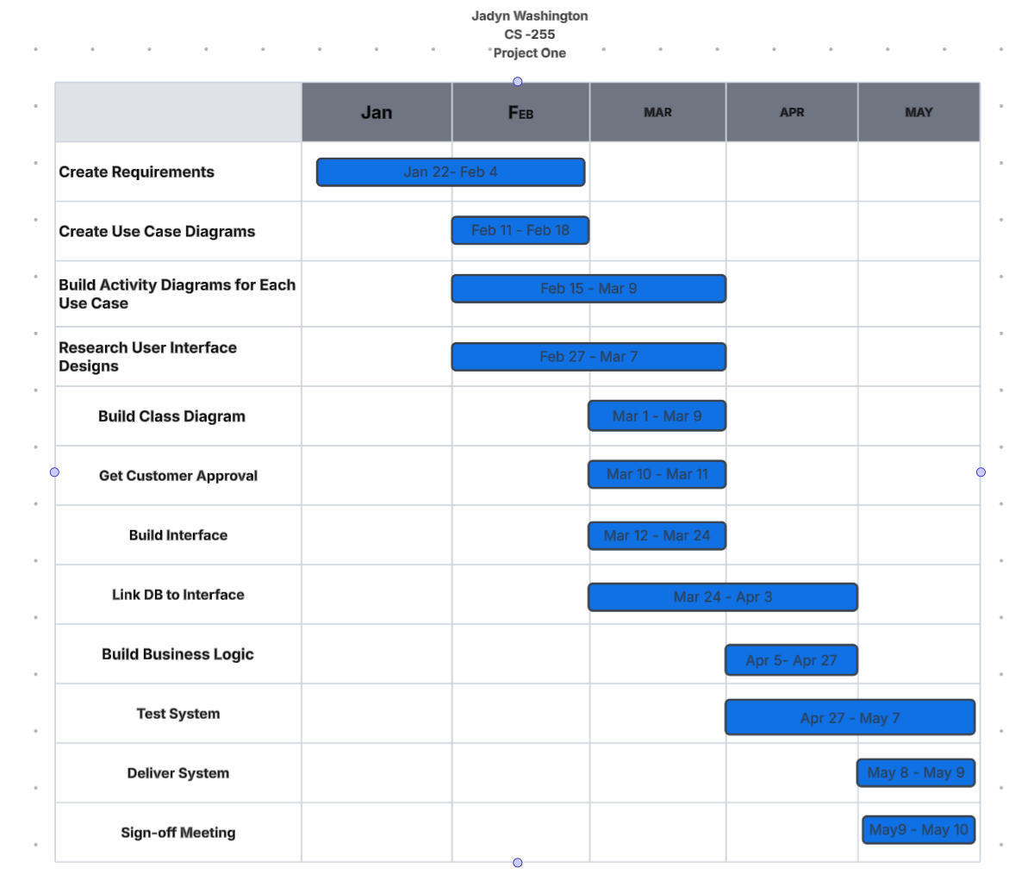

**Model Application**

* To apply process modeling to the Driver Pass project, I would start by defining goals like helping users prepare for driving tests, streamlining scheduling, and improving communication. Identify key stakeholders students, instructors, admins, developers to capture all perspectives gather user requirements through interviews or observations to understand current workflows and issues. I would also map existing processes with tools like flowcharts to spot inefficiencies then design an improved model with features like automated scheduling and real-time updates.
* In our Driver Pass project we use an object oriented approach to model key entities such as Student, Instructor, Course, Lesson, Schedule, Feedback, Test, and Payment. Each entity is defined by specific attributes for example a Student has properties like name, email, and enrolled courses, along with methods such as enrolling in a course or scheduling a lesson. The relationships between entities are also outlined, with a Student associated with multiple Courses and an Instructor working with multiple Students.

Stanke, B. (2023, March 25). Why is Business Process Modeling Important? — Helping Companies Deliver More Value Through Better Process Management | Bob Stanke. BOB STANKE. <https://www.bobstanke.com/blog/why-is-business-process-modeling-important>

Adkisson, H. (2022, March 22). Object Modeling for Designers: An Introduction - Heidi Adkisson - Medium. Medium. <https://hpadkisson.medium.com/object-modeling-for-designers-an-introduction-7871bdcf8baf>